Sponsor a hill tribe child - $60 per month 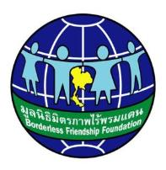
Thank you for your interest in sponsoring a hill tribe young woman.
We would like to introduce you to Khamnum who comes from Chiang Dao (north of Chiang Mai). Khamnum is in her second year of studies at university and hopes to be a teacher – she recently lost her sponsor.
OLH46 | Khamnum Lungyod  (Nickname: Pune) 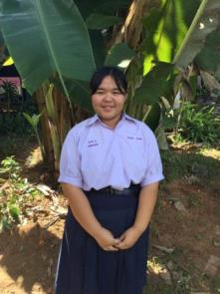 | 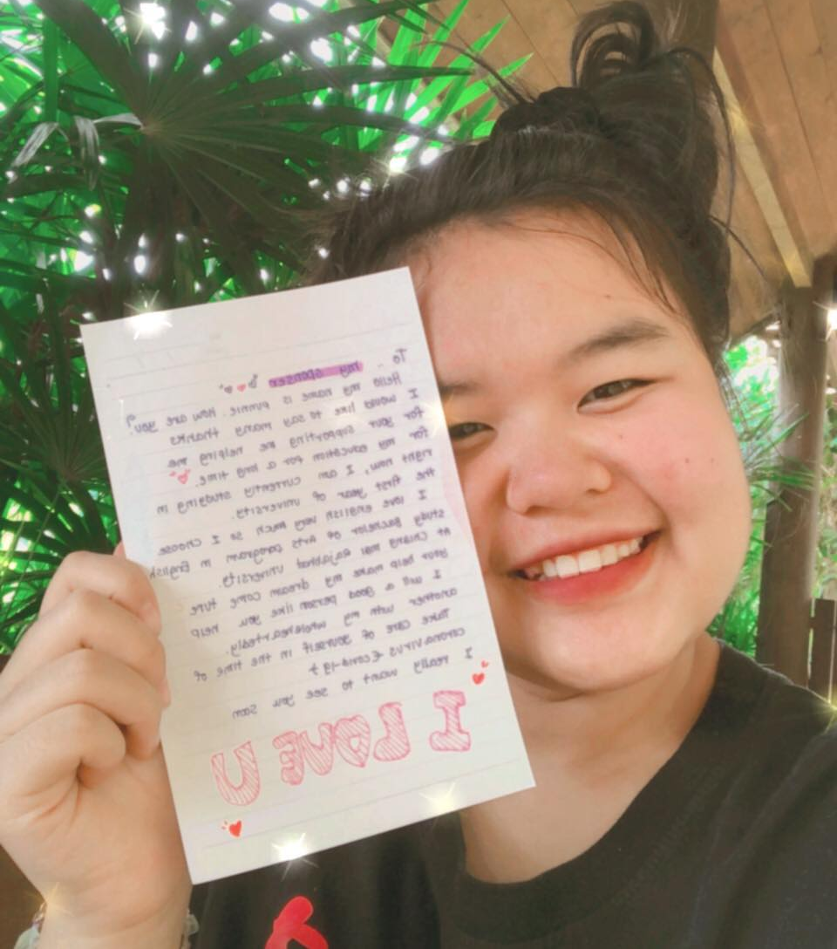 | Female  Shan tribe  19 year  2nd year Uni in April 2021  Education: English at Rajaphat Chiang Mai  Wants to be a teacher | Clever young woman. Has lived with aunt and then at Leadership Home. Now living with other hill tribe friends in Chiang Mai.
Borderless Friendship Western Australia works to enhance the lives of hill tribe children in Northern Thailand. We enable children/young people to continue at school. The opportunity for education will benefit them and their whole community. We know that keeping at-risk hill tribe children at school, helps eliminate child labour and the sale of children into drug running and child sex slavery. When faced with starvation, education becomes an extravagance.
We have found sponsors for 380+ hill tribe orphaned, abandoned or underprivileged children in Northern Thailand. Thanks to those generous sponsors, these children have food and essentials guaranteed each month.
The children come from remote hill communities – access to schools and health care is limited. The children live with volunteers in very basic accommodation at multiple sites near a school. They live in safety and learn skills. Many children have no family or come from single parent families. Sometimes parents are extremely ill or have died from AIDS and the children are without family support; these children stay permanently at the hostel. Khamnum lived with her aunt prior to going to Leadership Home. Her aunt worked away and was rarely there to care for Khamnum. Her aunt is extremely poor and unable to pay for her tertiary education. Our sponsorship program and scholarships is vital for her success.

We dream of sponsorship for all of these children/young people. We now have 58 young people going to technical school and university – the leaders of the future and Khamnum is one of them! By sponsoring her you will be supporting the next generation of young hill tribe people to reach their full potential.

You will receive annual updates, photos and communication with Khamnum. We do NOT deduct any handling fees or administration costs. You can be confident that all your funds reach her directly – into his bank account. If you have any questions at any time regarding the sponsorship program please do not hesitate to email us:
info-wa@borderlessfriendship.org

BANKING DETAILS: Borderless Friendship WA Inc
OLH48 This code enables us to track your sponsorship

Thank you for changing Khamnum’s life and giving her the opportunity of education.
Dr Lorel Mayberry, President and Sponsorship Coordinator

