Sponsor a hill tribe student - $60 per month 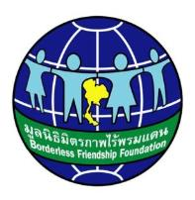
Thank you for your interest in sponsoring a hill tribe student.
We would like to introduce you to Ananyaporn who comes from a tiny village, Muang Ngai close to Leadership Home. She is in her first year of studies at university and hopes to be an engineer or mathematician.
OMN  62 | Ananyaporn Detboon  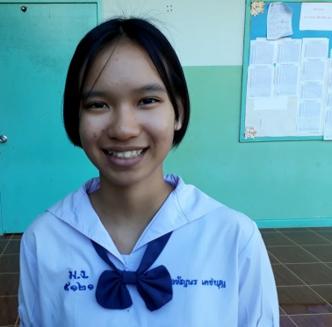 | 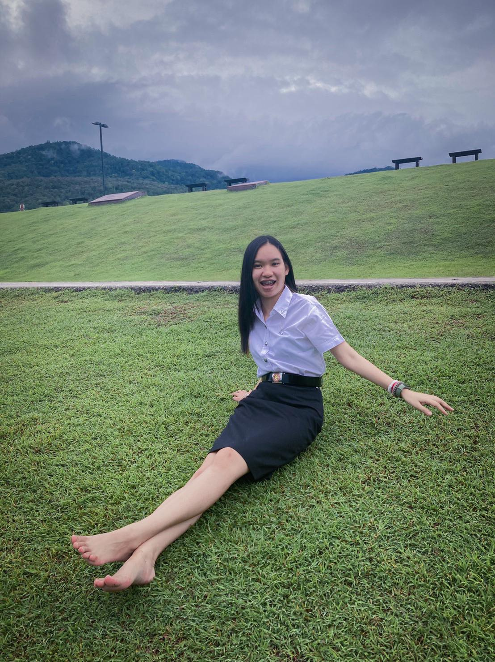 | Female  Shan tribe  19 year  Finished Grade 12 at Chiang Dao Wittyacom School  May 2021 - Chiang Mai University wants to be an engineer or mathematician.  Loves playing games with friends and family | Fabulous young Shan woman from Muang Ngai village (close to LH).  Mother, father and sister – very poor.  Tries hard with English – Science award for the district and gained entrance to CMU
Borderless Friendship Western Australia works to enhance the lives of hill tribe children in Northern Thailand. We enable children/young people to continue at school. The opportunity for education will benefit them and their whole community. We know that keeping at-risk hill tribe children at school, helps eliminate child labour and the sale of children into drug running and child sex slavery. When faced with starvation, education becomes an extravagance.
Together with our friends at Happy Hands Foundation (Victoria), we have found sponsors for 380+ hill tribe orphaned, abandoned or underprivileged children in Northern Thailand. Thanks to those generous sponsors, these children have food and essentials guaranteed each month.
The children come from remote hill communities – access to schools and health care is limited. The children live with volunteers in very basic accommodation at multiple sites near a school. They live in safety and learn skills. Many children have no family or come from single parent families. Sometimes parents are extremely ill or have died from AIDS and the children are without family support; these children stay permanently at the hostel. Ananyaporn has parents and they are extremely proud of her. They escaped from Myanmar for a better life for their clever daughter. They are extremely poor and unable to pay for her tertiary education.

We dream of sponsorship for all of these children/young people. We now have 58 young people going to technical school and university – the leaders of the future and Ananyaporn is one of them! By sponsoring her you will be supporting the next generation of young hill tribe people to reach their full potential.

You will receive annual updates, photos and communication with Ananyaporn. We do NOT deduct any handling fees or administration costs. You can be confident that all your funds reach her directly – into his bank account. If you have any questions at any time regarding the sponsorship program please do not hesitate to email us:
info-wa@borderlessfriendship.org

BANKING DETAILS: Borderless Friendship WA Inc
BSB 016510 Account no 533781137
Amount $60 Monthly OR $720 annually
OMN62 This code enables us to track your sponsorship

Thank you for changing Ananyaporn’s life and giving her the opportunity of education.
Dr Lorel Mayberry, President and Sponsorship Coordinator

